A. La Rosa Lecture Notes
INTRODUCTION TO QUANTUM MECHANICS
PART- I The TRANSITION from CLASSICAL to QUANTUM PHYSICS
________________________________________________________________
Appendix-2 of Chapter 3
Emission of radiation by an accelerated charge

Electromagnetic radiation is emitted by charges in accelerated motion.
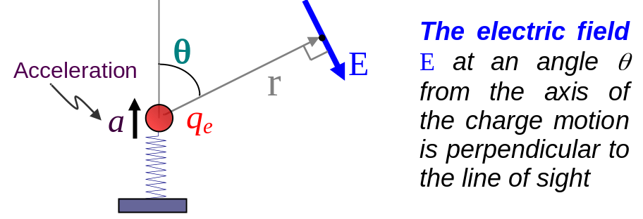
Fig. 1 An electron in an atom modeled as a charge attached at the end of a spring of appropriate spring constant or natural frequency 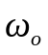 .

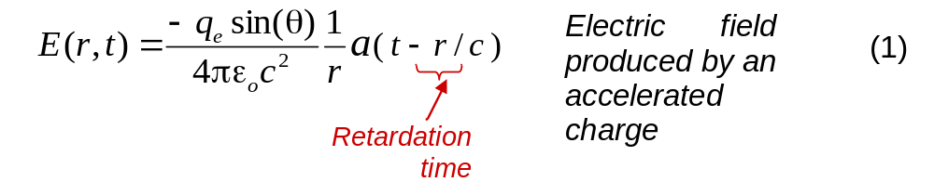

The Poynting vector 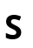
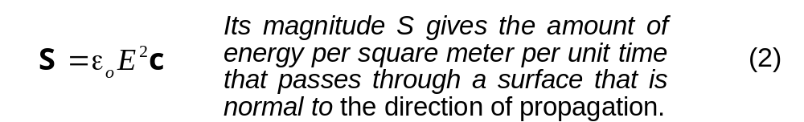

Radiation power P emitted by an accelerated charge

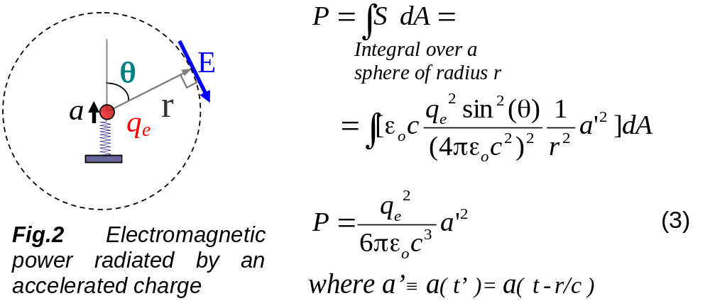
Emission of radiation by an oscillating charge
Consider that a charge 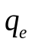 oscillates with angular frequency 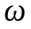
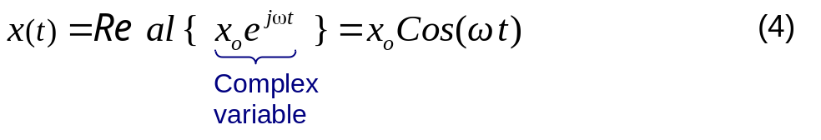
Here, 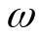 is not necessarily the natural frequency 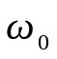 of the oscillator (see Fig 2). For example, the oscillator may be being driven by a external source of arbitrary frequency .

In what follows we will be evaluating time averages of physical quantities (i.e. 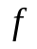) over one period 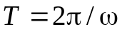 of oscillation:
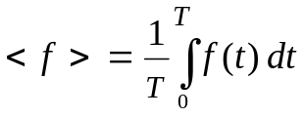 (5)
Notice, for example, that the time average of 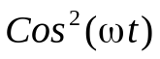 over one period is ½.
We also will be using indistinctly 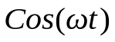 or 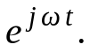 For the latter it is assume that we will take the real part after the calculations in order to obtain a proper (classical) physical interpretation.
From expression (19) we calculate an acceleration 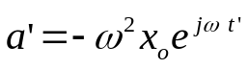 and 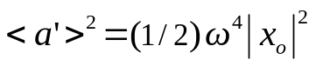. Replacing these values in expression (3) gives,
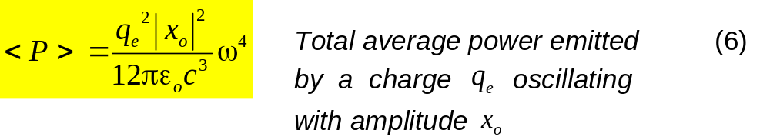
where 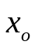 and are the amplitude and angular frequency of the charge’s oscillations, respectively.

